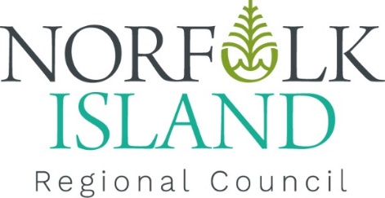

Community Announcement

Cargo ship arrival on Tuesday

A NIRC-chartered heavy lift ship, The BBC Emsland, is scheduled to arrive on Norfolk Island at 11.30pm on Tuesday, October 17, 2023, at Cascade Pier.

The weather forecast for Wednesday, 18 October is windy and consequently, the cargo unloading and lighterage may be delayed until Thursday 19 October 2023. Ship unloading is expected to take 5 days.

In addition, trucks will travel along Cascade Road to discharge heavy equipment and backload shipping containers. We ask for you to take care of your vehicle when driving during this period.

Residents and visitors are instructed to stay away from the viewing platform, west of the pier for safety reasons. For this reason, traffic control will be situated on Harpers Road/junction Prince Phillip Drive and Cascade Road/junction Youngs Road to restrict traffic during unloading.

