MEDIA RELEASE
Cockpit Creek Community Tree Planting
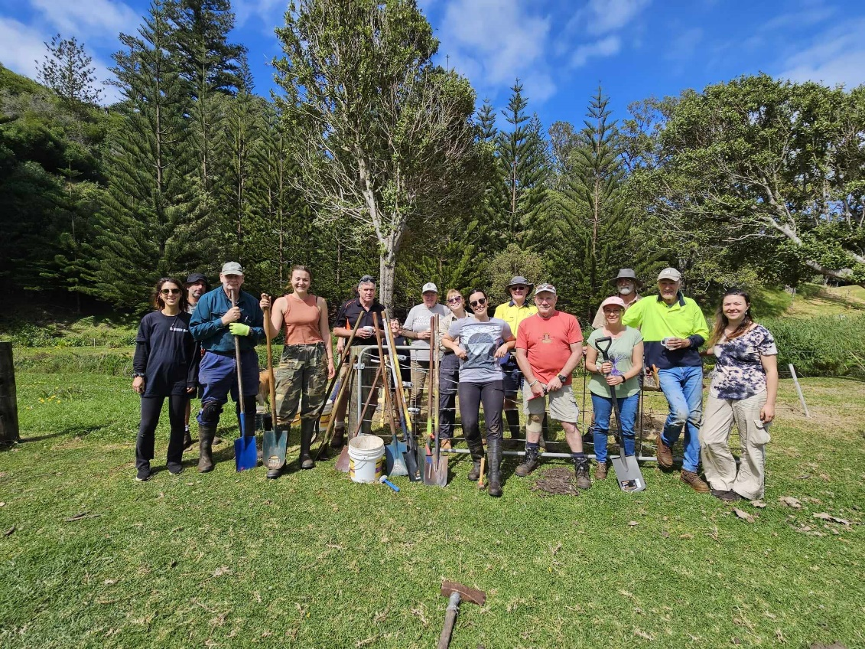
Last Sunday 17th saw to it that we were muddy and smiling! Our 3rd consecutive tree planting at Cockpit was a hit, with about 15 volunteers coming together to rehabilitate this riparian ecosystem. We planted 3 different species: Punga (Cyathea sp.), Melki Tree (Exoecaria agallocha) and Abutilon (Abutilon julianae). Part of the area planted was new ground, whilst the other half was adding to and diversifying an area of last year’s focus.

The creek is full of all kinds of native wetland species like Swamp Hibiscus (Hibiscus diversifolius), Slender Knotweed (Persicaria decipiens) and Drain Flax (Typha orientalis). The water is clear and flowing well and is a clear indication of improved health.
In the areas upstream of the current plantings we have begun to incorporate the cows back in to intermittently graze and manage the grass and weeds. We’re committed to keeping them out of the creek to minimise damage, but have erected temporary hotwires that give them access to much of the grass areas surrounding the creek. A great way to utilise cattle in assisting conservation.

Once again, thankyou to all the volutneers that came along to help out. It was nice to see some new faces this time as well. You guys make it all possible!

Stay tuned for our next community tree planting.


Thanks f mii

Lilli-Unna King
Environmental Project Officer
22nd September 2023

