MEDIA RELEASE
Argentine Ant Eradication Program Update
Norfolk Island Regional Council staff and contractors continue to undertake ground baiting in areas that have already been treated but small infestations persist. They also continue to monitor areas that have had ants previously as well as assess any new or suspected areas for Argentine Ants.

Once again, we have found another small infestation of Argentine Ants and we urge the community to be vigilant about not moving items that may harbour ants from known Argentine Ant zones. See map below. These items include but are not limited to firewood, green waste, timber, soil, plants, cuttings, fruit and vegetables, car wrecks and machinery. Even if the area has been treated it is not necessarily completely free of Argentine Ants. It can take several treatments to completely eradicate them from an area. An eradicated area needs to be free from ants for at least two years with regular monitoring.

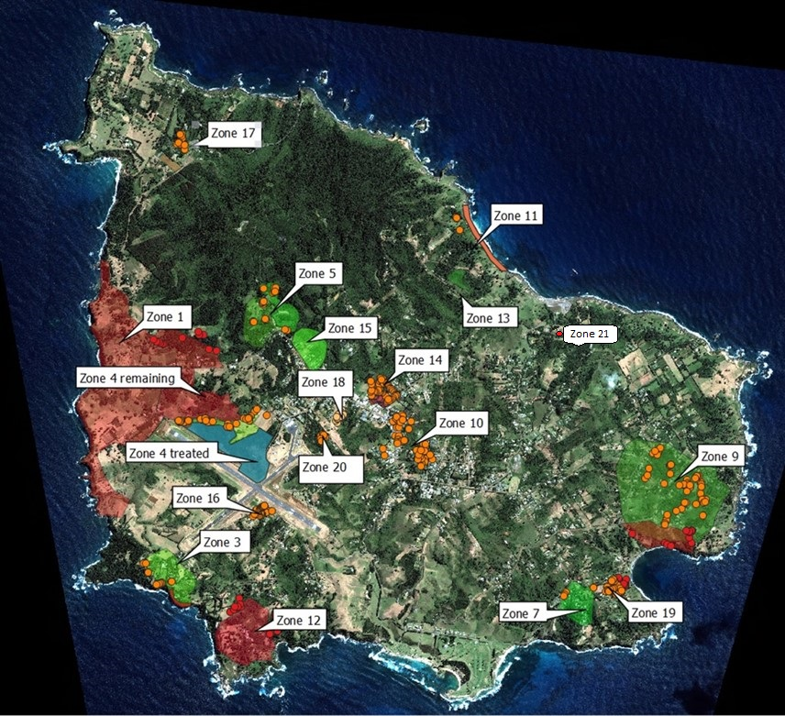

The new detector dog Sunny and handler Adam are progressing well with scent detection training and will hopefully be out in the field soon. If you see Sunny out, please do not interrupt her training or work. Finding Argentine ants needs to be the most fun/rewarding thing in her life.

Please remember to contact us if you think you have found Argentine Ants or you have any questions, please contact Customer Care on 22244, who will put you in contact with the Argentine Ant Eradication Program staff. Community support of the program and its methods are critical for eradication to be achieved and we thank you for your cooperation.
Tara Patel
TEAM LEADER BIODIVERSITY OFFICER
18 August 2023

