MEDIA RELEASE
Bumboras Community Tree Planting
We kicked off the tree-planting season last Sunday 16th, at Bumby! It was a lovely morning, with about 20 volunteers digging in and getting their hands dirty. Previous Bumboras plantings have occurred around the boardwalk and up on the hill. We changed it this year and focused on the rockery behind the toilet block. This area was cleared of Hawaiian Holly last year and has been waiting patiently for some TLC. There were small amounts of natural regeneration taking place, mainly in the form of native grasses and young pines. To this already beautiful area, we added Docks, Abutilon, Euphorbias, and other native ferns and hardwoods. It will be a sight as this area continues to grow, change, and mature!
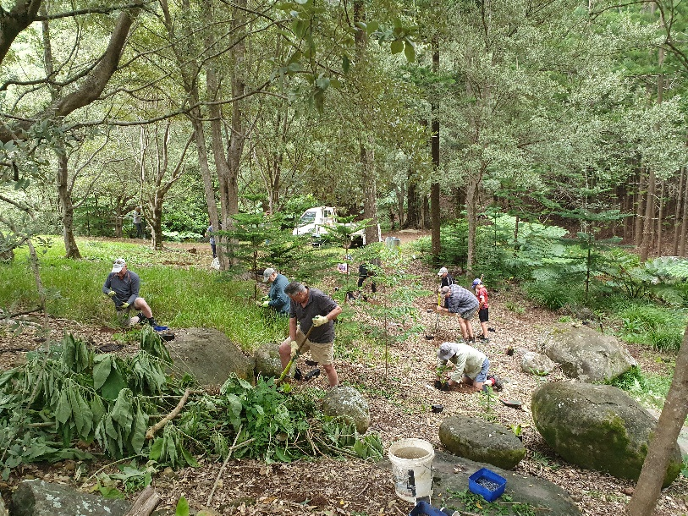
Regenerating our riparian areas (surrounding waterways and wetlands) is extremely important. Creeks sustain their own wild and wonderful array of creatures and support the surrounding forest and all the birds, plants, insects (and children) that reside there. And don’t forget, all rivers run to the sea. So the health of our creeks directly impacts the health of our ocean!

Something new that we incorporated into our process is washing and sterilizing our equipment before and after use. Phytophthora is a soil-borne pathogen that can cause widespread and often irreversible damage to forests and agricultural areas. It has been present on Norfolk for some time, but only recently have studies been done to determine the distribution of the pathogen. Phytophthora cinnamomi is arguably the most lethal strain as it is not host-specific and can affect many plants. Unfortunately, P.cinnamomi has been identified in various parts of Norfolk. Where there are known occurrences of Phytophthora, measures like boot scrub stations and signage have or will soon be put in place to mitigate the risk of spread. However, as there may be infected areas that we’re unaware of, possibly on private property, we’re taking all precautions to ensure that we don’t spread Phytophthora into our reserves or send it home with our volunteers either! We scrub our tools with Sterimax biocide to clean off any soil and kill unwanted pathogens. Remember, prevention is the best cure! For more information about P. cinnamomi on Norfolk go to the DITRDCA page and search ‘Phytophthora dieback on Norfolk Island: diagnosis and management’ or Click on the following link Phytophthora dieback on Norfolk Island: diagnosis and management | Department of Infrastructure, Transport, Regional Development, Communications and the Arts.

Thaenks, orl yorlyi, for coming along to join in. After digging, planting, staking, and watering, we sat down to enjoy a cuppa with some winter citrus and koknat bread. See you at our next planting on Sunday 30^{th,} location TBA.


Thaenks f mii
Lilli-Unna King
Environmental Project Officer
21st July 2023

