

Water Supply

Quality Assurance Program

**This program has been prepared by:**

(Insert name)

**This program is for:**

(Insert business name and address)

(Water carter)

**Date:** Insert date

Contents

Contents 2

Background 3

Water Supply Quality Assurance Program 3

1. Basic Information 5

1. 1 Private water supplier’s details 5

1. 2 Tanker details 5

1. 3 Water carter checklist 6

1. 4 Water supply system monitoring and maintenance personnel details (if different from above) 6

2. Description of the water supply system 7

2. 1 Diagram of the Water Supply System 9

2. 2 Equipment and chemical details 10

3. Risk Assessment of the Water Supply System 11

3. 1 Risk Assessment Template (Example risks included below – See Appendix A for possible controls) 12

4. Management Actions and Record Keeping 15

4. 1 Planned water supply system inspection and maintenance program 15

4. 2 Water quality monitoring program 16

4. 3 Water supply records 16

4. 4 Chlorination records 17

5. Contingency and Emergency Planning 18

5. 1 Contingency plan (example text included) 18

5. 2 Incident records 18

5. 3 Emergency contacts 19

APPENDIX A Common sources of contamination (hazards) and suggested control measures 20

APPENDIX B Identification of risk 22

APPENDIX C Possible water supply system inspections 23

APPENDIX D Cleaning and disinfection 24

APPENDIX E Record tables 26

Background

The [*Public Health Act 2010* (NSW)](https://www.legislation.nsw.gov.au/#/view/act/2010/127) is applied to Norfolk Island under the *Norfolk Island Applied Law Ordinance 2016*. Section 25 of the [*Public Health Act 2010* (NSW)](https://www.legislation.nsw.gov.au/#/view/act/2010/127) requires that all suppliers of drinking water establish and adhere to a Quality Assurance Program (QAP). This template will help private water suppliers develop a QAP and can be altered to ensure it is relevant to each water supply system.

A QAP must address the Framework for Management of Drinking Water Quality set out in the *Australian Drinking Water Guidelines* (ADWG 2011), in a way that is appropriate to each water supply. The *Australian Drinking Water Guidelines* are available at:

<http://www.nhmrc.gov.au/guidelines/publications/eh52>

The *NSW Private Water Supply Guidelines* provide additional guidance for private water suppliers to develop a QAP (the guidelines are for an Act that is identically worded to the Norfolk Island Public Health Act) and are available at:

<http://www.health.nsw.gov.au/environment/water/Documents/NSW-Private-Water-Supply-Guidelines.pdf>.

Further information can be found by contacting Norfolk Island Regional Council.

Water Supply Quality Assurance Program

This template document is based on the NSW Health private water supplier template and has been modified for use on Norfolk Island.

A water supply system includes everything from the collection of the source water through to the point of use. When developing a Quality Assurance Program (QAP) for a water supply system an operator should ask three questions:

What problems could occur between the water source and the point of use?

How can they be prevented or fixed?

How do you know that the problem has been prevented or fixed?

The answers to these questions will help determine how to:

Assess and protect the quality of the source water

Make sure treatment processes are appropriate, maintained and working properly

Regularly test the water quality

Make the water supply safe if contamination has occurred

Make sure that water users are warned and/or provided with safe drinking water if the normal supply is found to be unsatisfactory or the quality cannot be guaranteed.

Keeping the water supply system safe involves:

Identifying who is responsible for the system and who will respond to issues

Understanding hazards to your water sources

Making sure the water is stored and distributed safely

Treating the water to remove or control any contamination

Monitoring the quality of the water and the integrity of the water supply system

Planning how to respond to problems in the water supply system.

Your QAP should reflect the type of water supply system you manage, especially the water source and its end uses.

If the water supply is not monitored or treated and is not required to be of drinking water quality (water used in food preparation must be drinking water quality), operators may choose to manage their risk by placing signs at outlets to warn consumers not to consume the water.

See the *NSW Private Water Supply Guidelines* for information on signage. A QAP must still be developed and should include details on all signage.

If you use water to prepare food under the *Sale of Food Act 1950 (NI)* (i.e. hold a current Norfolk Island sale of food license appropriate) water treatment must be installed.

What to do with the QAP

You must provide a copy of the completed QAP to Council via email at [customercare@nirc.gov.nf](mailto:customercare@nirc.gov.nf) .

The QAP should be a living document that is reviewed regularly. Any changes that occur to the water supply system or any new hazards that are identified from observations, equipment checks, incidents or monitoring should be added to the relevant section of the program.

Your QAP should be kept in a central place that is easily accessible to staff and others who may need to view it, such as officers of the Norfolk Island Regional Council.

**The activities in this QAP are undertaken by this business to ensure safe drinking water and to protect public health.**

# Basic Information

## Private water supplier’s details

|  |  |
| --- | --- |
| **Business name** |  |
| **Owner name** |  |
| **Contact details** | Phone:  Mobile Phone:  Email:  Address: |
| **Business after-hours / emergency contact** | Name:  Phone:  Mobile Phone:  Email:  Address: |

## Tanker details

|  |  |  |  |
| --- | --- | --- | --- |
| **Tanker** | **Vehicle Registration Number** | **Tanker volume** | **Tank is made of?** |
|  |  |  | e.g. stainless steel |
|  |  |  | e.g. aluminium tank with an epoxy lining |
|  |  |  |  |

## Water carter checklist

| **Item** | **Yes / No** | **Provide details** |
| --- | --- | --- |
| Tank/s, hoses and fittings are made of material that will not contaminate drinking water? |  | e.g. food grade stamp, marked as AS/NZ 4020 and AS 2070 |
| The tanker/s is flushed, cleaned and disinfected? |  | When, how and chemical used |
| The hose fittings are caped, stored and cleaned? |  | When and how |

## Water supply system monitoring and maintenance personnel details (if different from above)

|  |  |
| --- | --- |
| **Role** | **Contact details** |
| E.g. Routine maintenance/plumber | Name:  Phone:  Email: |
| E.g. Water testing | Name:  Phone:  Email: |
| Add more rows as required |  |

# Description of the water supply system

Describe the details of your water system from source to customer (Delete any that are not relevant and modify or add text as required, tick where appropriate).

| **Tick** | **Component** | **Description** |
| --- | --- | --- |
| **Tanker source water** | | |
| ✓ | Groundwater (bore) | 1 x groundwater bore  Shallow surface connected aquifer {Include details of bore location, including depth, casing type} |
|  | Rainwater (roof water) |  |
|  | Other |  |
| **Treatment** | | |
|  | Filtration | All water is filtered {include filtration system details} |
|  | UV disinfection | All water undergoes UV treatment {Include UV system details here} |
|  | Chlorination | All water is chlorinated {include chlorine dosing system details} |
|  | Storage/header tank | 1 x storage tank receiving water from bore  {Describe location of tank, tank material, size, lining, distance from bore, covering} |
|  | First flush diverter (rainwater tanks) |  |
|  | Other |  |
| **Tankers** | | |
|  | Tanker materials |  |
|  | Tanker cleaning and disinfection |  |
|  | Pipes | {Describe pipe material) |
|  | Pumps | 1 x distribution pump  1 x bore / dam pump |

## Process flow diagram

Draw a simple diagram of your water supply system. Show the water source, pumps, storage, treatment, pipelines and uses. Include the location of wastewater systems (for example, septic tanks), any possible sources of contamination and the location of physical control measures such as fences, signs, etc. The diagram must reflect the details of the water supply system but does not need to be to scale.

Key for drawings

|  |  |  |  |
| --- | --- | --- | --- |
| **Item** | **Icon** | **Item** | **Icon** |
| Building or structure (with roof) |  | Hotel / cabins |  |
| Tank |  | Water carter |  |
| Bore |  | First flush device |  |
| Filter |  | Valve (back-flow prevention device) |  |
| Pump |  | UV disinfection |  |
| Septic tank |  | Agricultural or other customers |  |
| Pipes |  | Chemical dosing |  |

Example water carter diagram {Update with your system details}



Watermill Dam

Pump

20 kL Reservoir

20 kL Reservoir

Pump

Consumer

Bore

Filter

Outlet filter

UV disinfection

UV disinfection

Water carter Tanker 2

Water carter Tanker 1

Chlorine

Pour ‘n Go

## Equipment and chemical details

Details of pumps, parts, treatment systems and chemicals are recorded in this section. The manufacturer’s instructions are attached to the QAP {Attach manufacturer’s instructions or reference location}.

Check all chemicals are suitable for potable water use.

### Equipment and chemical records

| **Part / Equipment** | **Manufacturer** | **Supplier/Repairer  Contact Details** | **Manufacturers instruction location** | **Critical spares (held on site)** |
| --- | --- | --- | --- | --- |
| Water pumps |  |  |  |  |
| Filters |  |  |  |  |
| UV system |  |  |  |  |
| Chemical |  |  |  |  |
| *Add extra lines as required* |  |  |  |  |

# Risk Assessment of the Water Supply System

Understanding the risks to your water supply is a crucial step in ensuring its safety. Actions should be prioritised on the basis of level of risk.

The hazards to the water supply are considered and rated following the advice in the QAP template, examples are included in Appendix A. The *NSW Private Water Supplies* *Guidelines* can also be used for guidance. Note all controls which are in place to address the hazards, and actions required to ensure the ongoing protection of water quality. Use the following risk assessment process.

Document your risk assessment in the next template table, using the following steps. Create as many pages as required. It is important to review your risk assessment regularly to ensure any new risks are identified.

**Step 1:** Identify particular hazards in the water supply in the risk assessment template.

The table in Appendix A gives examples of some hazards and is provided to assist in completing the “Hazard” column of the Risk Assessment.

**Step 2:** Assign risk rankings.

Once all possible hazards are listed, assign a risk ranking to each hazard of low, medium or high in the risk assessment template. Consider the likelihood of the hazard occurring and, if it does, the severity of the consequence. The table in Appendix B may assist in ranking risks.

**Step 3:** Identify controls.

Decide whether the hazards identified in the system have controls in place and describe these controls in the risk assessment template. Controls are the ways that risks will be managed, for example excluding animals from dams used for human drinking water, regular inspection and maintenance programs or water treatment. The table in Appendix A gives some more examples of possible controls for various hazards.

Decide whether the controls used are adequate for the identified risk (Step 1).

**Step 4:** Monitoring of controls is important to ensure they are working effectively.

Describe in the risk assessment template how, when and where monitoring will occur, who is responsible, how and where records will be kept and by whom. Consult the *NSW Private Water Supply Guidelines* for information on monitoring.

**Step 5:** Where hazards are identified, consider what could be done to improve safety, reduce the risk of those hazards or improve water quality.

List any shortcomings in your water supply system and its management and identify what improvements should be made. Document these improvements in your risk assessment template.

**Step 6:** Prioritise actions that need to be taken to protect the water supply and give them a priority number or time frame in the risk assessment template.

## Risk Assessment Template (Example risks and controls included below)

## See Appendix A for more possible controls and update with your program

| **Step 1** | **Step 2** | **Step 3** | | **Step 4** | **Step 5** | **Step 6** |
| --- | --- | --- | --- | --- | --- | --- |
| **Hazard** | **Risk Rank** | **What control measures are used?** | **Is the Hazard adequately controlled?** | **How is this control monitored?** | **What could be done to improve safety?** | **Timeframe for action** |
| Tanker: Contaminated water in tanker | High |  |  |  |  |  |
| Bore water source: Contamination from surface water runoff into bore casing | High | Raise bore heads above ground level and mound up ground around bore head  Ensure bore covers and casing are intact  Regular inspections  Fence to prevent animal access to bore head |  |  |  |  |
| Bore water source: Poor operation or condition of on-site sewage management system | High | Extract groundwater from places where sub-surface contaminants are unlikely  Test the water for chemicals and treat if necessary  Groundwater source is at least 20 metres from any wastewater disposal systems  Water treatment (disinfection) |  |  |  |  |
| Bore water source: Contaminated ground water in aquifer | Medium - high[1] | Extract groundwater from places where sub-surface contaminants are unlikely  Test the water for chemicals and treat if necessary  Groundwater source is at least 20 metres from any wastewater disposal systems  Water treatment (disinfection) |  |  |  |  |
| Surface water source: Contaminated dam water from animal grazing or human use | High | Fence water storage or off-take area  Don’t permit swimming or public access in off-take area  Protect surface water source against livestock, septic tanks/sewage overflows and chemical spills  Water treatment |  |  |  |  |
| Surface water source: Algal bloom in dam | High | Regular inspections  Protect surface water source against chemical spills and stormwater potentially contaminated with fertiliser  Water treatment |  |  |  |  |
| Surface water source: Contamination of surface water by animal carcasses or faeces | High | Regular inspections  Fence water storage or off-take area  Protect surface water source against livestock  Water treatment |  |  |  |  |
| Storage tanks: Contamination from insect, birds and animals entering the storage tank | High | Screen all inlets and outlets to the tank  Regular inspections of tank, roof and gutters |  |  |  |  |
| Fittings:  Low pH of water corroding plumbing fittings when the taps haven’t been used so water sits in pipes | Low | All materials in contact with water comply with AS/NZS 4020:2005 |  |  |  |  |
| Fittings:  Corrosion of metal plumbing fittings by soft water e.g. copper from pipes resulting in blue water | Low | All materials in contact with water comply with AS/NZS 4020:2005 |  |  |  |  |
|  |  |  |  |  |  |  |
|  |  |  |  |  |  |  |
|  |  |  |  |  |  |  |
|  |  |  |  |  |  |  |
|  |  |  |  |  |  |  |
|  |  |  |  |  |  |  |
|  |  |  |  |  |  |  |

# Management Actions and Record Keeping

Document all activities required to manage the water supply including inspections, maintenance, signage, monitoring, and incident management.

Records of the following should be kept either in a log book diary, example record tables are included in Appendix E

All inspections, maintenance, carted water or incidents/emergencies. These records include system inspections

All results of microbial and chemical testing, and chlorine levels (where applicable)

Maintenance to the water system such as tank cleaning, filter change, chlorination

Incidents and corrective actions e.g. dead animal in storage tank, storms, treatment breakdown

## Planned water supply system inspection and maintenance program

An inspection regime should address all aspects of the water supply system. Regular inspection and maintenance is essential to maintaining a well-functioning and safe water supply.

Consult the equipment instruction manuals for the frequency of inspection and maintenance activities required.

Record maintenance and inspection activities in a log sheet or diary (example included in Appendix E).

### Planned inspection and maintenance program (examples included)

| **What is to be inspected/maintained** | **How often it is to be inspected/maintained  (frequency or dates)** | **Who should conduct the inspection/maintenance** | **Any equipment or procedures needed** |
| --- | --- | --- | --- |
| Water carter tanks are flushed, cleaned and disinfected | 3 months |  |  |
| Clean hoses and fittings | Monthly |  |  |
| Chlorine storage area | Monthly |  |  |
| Top up fuel for pump | Weekly |  |  |
| UV system inspection | Daily |  |  |
| Clean filters | Monthly |  |  |
| Check filter integrity | As per equipment manual |  |  |
| Inspect well head is secure and free from water pooling | Monthly or after heavy rains |  |  |
| Structural condition of storage tank | Annually |  |  |
| System (pump, piping, bore casing) is fully operational and maintained | Annually |  |  |
| Drain storage tank to remove sludge build-up | Every 2 years |  |  |
| Check UV system is operating correctly | Weekly |  |  |
|  |  |  |  |

## Water quality monitoring program

Water quality monitoring is important in ensuring controls are effective and in response to concerns.

### Water quality monitoring {Example provided, update with your program}

| **What is to be monitored** | **How often are tests to be taken (frequency or dates)** | **Location of tests** | **Who should perform the test** | **Equipment needed and procedures for performing the test** |
| --- | --- | --- | --- | --- |
| On site tests  e.g. pH, chlorine | Daily when chlorine is used | Treated water from each bore |  | Test Kit  Procedures are written on the lid of test kit. |
| Water quality | Daily when water is being carted | Treated water from each bore |  | Taste & odour |
| *E. coli* | Monthly during months when water is being carted | Treated water from each bore | Council |  |
| Chemical | Annually | Treated water from each bore | Council |  |

## Water supply records

Records should be kept for at least 6 months of:

The location of each water supply that water is sourced from

The name and address of each customer

The place, date, time and volume of water for each customer delivery

Details of any liquids / substances other than drinking water put in the water tanker/s

The dates water tanker/s are cleaned

## Chlorination records

For guidance on the safe use of chlorine see Chapter 5 of the *NSW Private Water Supply Guidelines.*

If chlorine is used, record details in a log sheet or diary (example included in Appendix E).

# Contingency and Emergency Planning

Document what to do:

If there is a problem with an important part of the water supply system

In response to a failed water quality test

To ensure all people responsible for the water supply system have the knowledge and skills to run the system, e.g. training temporary managers

In response to customer complaints regarding water quality

In response to any other issue

## Contingency plan (example text included, update with what you would do)

|  |  |
| --- | --- |
| **Issue** | **Likely actions that could be taken** |
| Dirty or smelly water | Flush lines  Check operation of filters  Check water quality in tank  Use bottled water for drinking, food preparation, cleaning teeth |
| Unpleasant taste to water | Flush lines  Check operation of filters  Check water quality in tank  Use bottled water for drinking, food preparation, cleaning teeth |
| Positive *E. coli* test | Do not supply water  Contact Norfolk Regional Island Council for advice  Re test water for *E. coli*  Check operation of filters  Check tank integrity  Check bore head integrity (if relevant) |
| UV lamp no available for replacement | Do not supply water  Acquire functional lamp and a spare |
| Vermin (birds, rats, etc.) found in tank or tanker | * Do not supply water * Contact Norfolk Island Regional Council for advice * Drain and clean tank * Test water for *E. coli* prior to resupply |
|  |  |

## Incident records

If incidents, issues or emergencies occur that impact on the water quality, record what happened and what was done to rectify the situation. Include any customer complaints about water quality.

Record details in a log sheet or diary (example included in Appendix E).

## Emergency contacts

Keep details of who to contact in an emergency, who to call for advice and important local contractors. Keep these details in an easily accessible place.

| **Contact** | **Name** | **Contact Details** |
| --- | --- | --- |
| Norfolk Regional Council |  |  |
| Plumber |  |  |
| Chlorine Supplier |  |  |
| Electrician |  |  |

###### APPENDIX A Common sources of contamination (hazards) and suggested control measures

| **Component** | **Potential source of contamination** | **Control measures** |
| --- | --- | --- |
| Water Source | Rain water  Roof and gutters (e.g. build-up of leaves, dirt and animal droppings) | First flush device  Regular cleaning of roof and gutters  Removal of overhanging branches  Regular inspections  Water treatment (disinfection) |
| Rain water  Roof material (e.g. lead-based paint, lead flashing, bitumen-containing products, treated timber, peeling paint) | Water not collected from roofs coated or painted with substances that may leach hazardous materials  Remove or treat lead flashing  Seal any exposed treated timber |
| Surface water (dams, creeks and rivers)  Surrounding land use (e.g. farming, urban areas, industrial sites and sewage discharges) | Protect surface water source against livestock, septic tank/sewage overflows and chemical spills  Water treatment |
| Surface water (dams, creeks and rivers)  Animal and human activities | Fence water storage or off-take area  Don’t permit swimming or public access in off-take area  Water treatment |
| Groundwater (bore, well, spring)  Surface water seepage | Raise bore heads above ground level and mound up ground around bore head  Ensure bore covers and casing are intact  Regular inspections |
| Groundwater (bore, well, spring)  Sub-surface contamination (e.g. from industry, farming, landfill, sewage) | Extract groundwater from places where sub-surface contaminants are unlikely  Test the water for chemicals and treat if necessary  Groundwater source is at least 20 metres from any wastewater disposal systems  Water treatment (disinfection) |
| Water Storage | Insect, birds and animals in system | Screen all inlets and outlets to the tank  Regular inspections of tank, roof and gutters |
| Build up of sludge in tank, dirt in inlet strainers or insect screens | Regular inspection, cleaning and maintenance program |
| Tank materials (e.g. pH of water in concrete tanks, high metals from metallic tanks) | Materials in contact with water comply with relevant Australian Standards (refer to Appendix 1)  Chemical adjustment of pH in new concrete tanks may be necessary |
| Backflow water (e.g. from animal water troughs) | Backflow prevention device |
| Distribution system | Pump and plumbing materials | All materials in contact with water comply with AS/NZS 4020:2005 |
| Leaching from bore casings, pipes or plumbing materials | All materials in contact with water comply with AS/NZS 4020:2005  Flush standing water at irregularly used fixtures |

###### APPENDIX B Identification of risk

|  |  |  |  |
| --- | --- | --- | --- |
|  | Consequence | | |
| Likelihood | Minor | Moderate | Major |
| Rare | Low Risk | Low Risk | Medium Risk |
| Possible | Low Risk | Medium Risk | High Risk |
| Likely | Low Risk | Medium Risk | High Risk |

To identify a risk as low, medium or high, use the above matrix of likelihood and consequence. As an example: A hazard with rare likelihood but major consequence will be assigned a medium risk. Events that may cause sickness would be assigned a major consequence, for example bacterial contamination of a dam or rainwater tank, or an algal bloom in a dam.

**Likelihood** can be assessed as

Rare: the hazard may only occur in exceptional circumstances, for example every 2 to 5 years

Possible: the hazard might occur or should occur at some time, for example 2 to 4 times per year

Likely: the hazard will probably occur in most circumstances, for example every month

**Consequence** can be assessed as

Minor: causing a minor impact on a small number of people, some manageable operational disruption, or some increase in operating costs, for example consequences which can be managed by normal operations

Moderate: causing a minor impact on more people, significant modification to normal operations but manageable, operation costs increased, or increased monitoring, for example consequences that may involve additional time and expense to manage

Major: causing a major impact for any number of people, system significantly compromised, operation abnormal if operating at all, high level of monitoring required. Any consequence involving consumers falling ill should be considered major.

###### APPENDIX C Possible water supply system inspections

A range of inspections may need to be conducted on various aspects of the water supply system. Possible inspections include:

Water source–– rainwater and bore water

* Check upstream for contamination (monthly or after heavy rains)
* Check the fenced livestock area (monthly)
* Check well head is secure and free from water (monthly or after heavy rains)
* Check maintenance and operation of pump (annually)
* Check rainwater roof for overhanging vegetation (as required)
* Clean gutters (as required)

Storage tank

* Check inlet and outlet screens (3 monthly)
* Check access covers (3 monthly)
* Clear strainer for debris (3 monthly and after heavy rains)
* Check for presence of mosquito larvae in tank water (3 monthly)
* Check structural condition (annually)
* Check sludge level and internal cleanliness (every 2 years or as required)
* Check roof condition and ensure no overhanging trees (3 monthly)

Treatment system

* Check plumbing/piping is fully operational and well-maintained (annually)
* Check treatment system is operating as per manufacturers advice
* Replace filters (as per manufacturer’s advice or earlier if a decrease in water flow is noticed)
* Test chlorine level is at or above 0.5 mg/L (regularly as per Private Water Supply Guidelines)
* Check UV light is operating (daily)
* Check UV light is visually free from scum (as per manufacturer’s advice)
* Replace UV light source (as per manufacturer’s advice)
* Other treatment (as per manufacturers advice)

Water tanker

* Check sludge level and internal cleanliness (every 2 years or as required)
* Check structural condition (annually)

###### APPENDIX D Cleaning and disinfection

The following are an extract from the *NSW Health Guidelines for Water Carters, 2016*

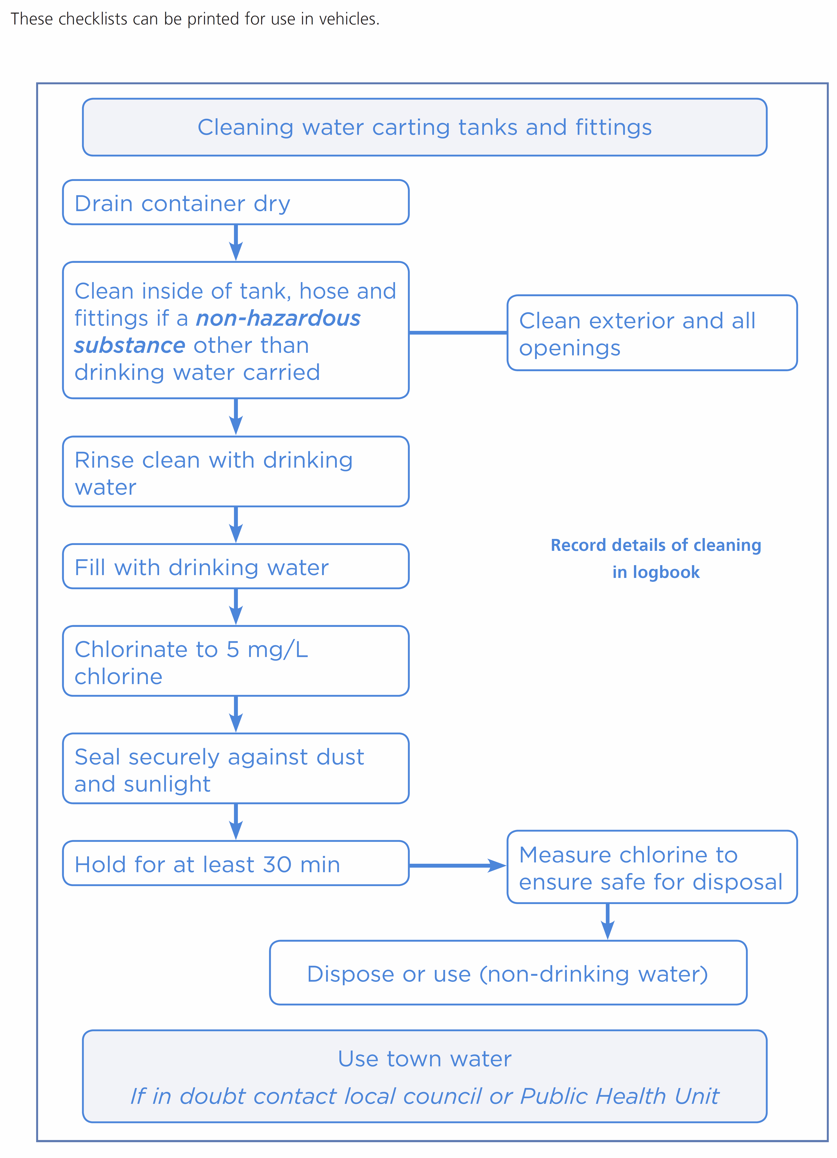

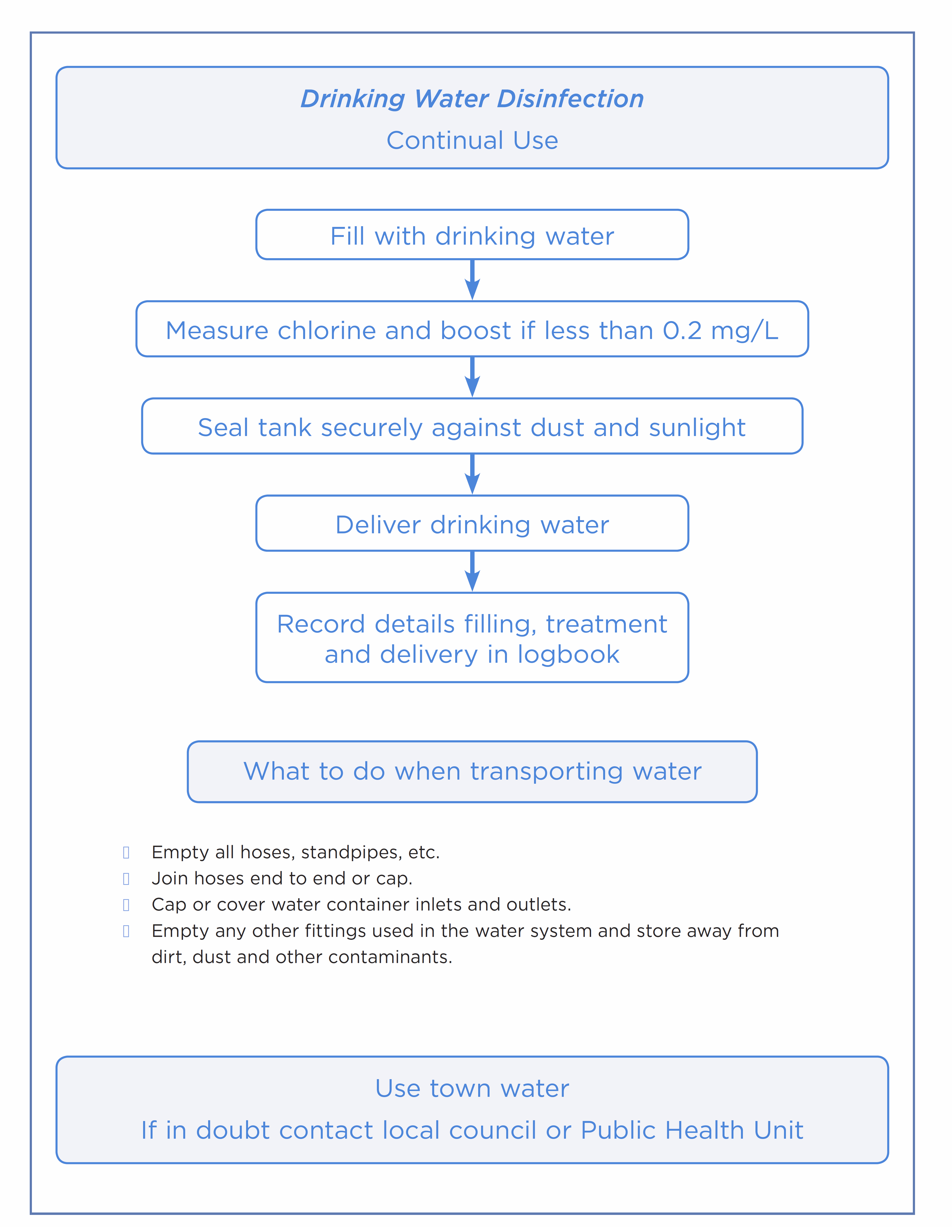

###### APPENDIX E Record tables

### Inspection and maintenance record (planned and reactive)

| **Date** | **What was inspected / maintained** | **Notes** | **Actions to be taken** | **Person Responsible** |
| --- | --- | --- | --- | --- |
|  | e.g. monthly disinfection of tanker | Sodium hypochlorite used to disinfect tanker | N/A |  |
|  |  |  |  |  |
|  |  |  |  |  |
|  |  |  |  |  |
|  |  |  |  |  |
|  |  |  |  |  |
|  |  |  |  |  |
|  |  |  |  |  |
|  |  |  |  |  |
|  |  |  |  |  |
|  |  |  |  |  |
|  |  |  |  |  |
|  |  |  |  |  |
|  |  |  |  |  |
|  |  |  |  |  |
|  |  |  |  |  |
|  |  |  |  |  |
|  |  |  |  |  |
|  |  |  |  |  |
|  |  |  |  |  |

Make a record every time the water is tested, detailing what was tested, when, results and actions.

### Water testing results

| **Date** | **Where test was taken from** | **Type of test taken** | **Test Result** | **Any action taken** | **Person Responsible** |
| --- | --- | --- | --- | --- | --- |
|  |  |  |  |  |  |
|  |  |  |  |  |  |
|  |  |  |  |  |  |
|  |  |  |  |  |  |
|  |  |  |  |  |  |
|  |  |  |  |  |  |
|  |  |  |  |  |  |
|  |  |  |  |  |  |
|  |  |  |  |  |  |
|  |  |  |  |  |  |
|  |  |  |  |  |  |
|  |  |  |  |  |  |
|  |  |  |  |  |  |
|  |  |  |  |  |  |
|  |  |  |  |  |  |
|  |  |  |  |  |  |
|  |  |  |  |  |  |
|  |  |  |  |  |  |
|  |  |  |  |  |  |

### Delivered water (Store records for 6 months)

|  |  |  |  |  |  |
| --- | --- | --- | --- | --- | --- |
| **Water source (which bore)** | **Date / time delivered** | **Recipient** | **Delivery address** | **Volume supplied** | **Chemical dosed** |
|  |  |  |  |  |  |
|  |  |  |  |  |  |
|  |  |  |  |  |  |
|  |  |  |  |  |  |
|  |  |  |  |  |  |
|  |  |  |  |  |  |
|  |  |  |  |  |  |
|  |  |  |  |  |  |
|  |  |  |  |  |  |
|  |  |  |  |  |  |
|  |  |  |  |  |  |
|  |  |  |  |  |  |
|  |  |  |  |  |  |
|  |  |  |  |  |  |
|  |  |  |  |  |  |
|  |  |  |  |  |  |
|  |  |  |  |  |  |
|  |  |  |  |  |  |
|  |  |  |  |  |  |
|  |  |  |  |  |  |

### Chlorination records

| **Date** | **Volume of water treated (litres)** | **Amount of chlorine added** | **Free chlorine test result (mg/L)** | **Person responsible** |
| --- | --- | --- | --- | --- |
|  |  |  |  |  |
|  |  |  |  |  |
|  |  |  |  |  |
|  |  |  |  |  |
|  |  |  |  |  |
|  |  |  |  |  |
|  |  |  |  |  |
|  |  |  |  |  |
|  |  |  |  |  |
|  |  |  |  |  |
|  |  |  |  |  |
|  |  |  |  |  |
|  |  |  |  |  |
|  |  |  |  |  |
|  |  |  |  |  |
|  |  |  |  |  |

mg/L = milligrams per litre, this is the same as ppm (parts per million)

### Incident records

| **Date** | **Incident** | **Notes and corrective actions** | **Person Responsible** |
| --- | --- | --- | --- |
|  | e.g. Dirty water noticed coming from tap | e.g. Heavy rains after dry spell washed dirt into rainwater tank and resuspended sludge as tank level was low. Potential for bacterial contamination. Tank has not been cleaned recently. Advised customer to boil water before use and supplied bottled water to rooms. Booked tank cleaner and water carter to refill tank. Checked roof and gutters. Checked first flush diverter. |  |
|  |  |  |  |
|  |  |  |  |
|  |  |  |  |
|  |  |  |  |
|  |  |  |  |
|  |  |  |  |
|  |  |  |  |
|  |  |  |  |
|  |  |  |  |
|  |  |  |  |
|  |  |  |  |
|  |  |  |  |
|  |  |  |  |

1. Risk may vary depending on location on island. More information available from council.