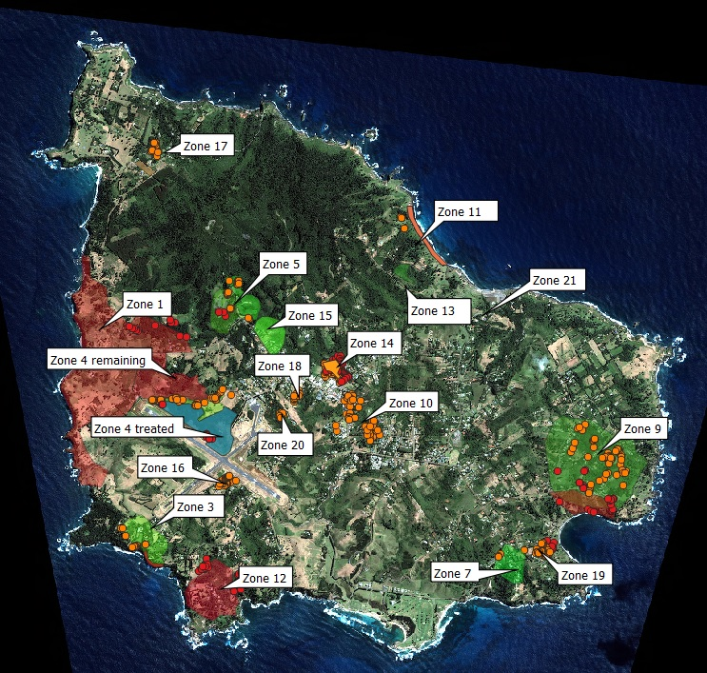

Figure 1: Extent and location of known Argentine ant infestations on Norfolk Island as of August 2023. Red zones are those that remain untreated, orange areas are currently undergoing treatments, and green zones are those where treatments have been undertaken and monitoring continues.